Experiment No: 1

Title: Demonstrate inline, internal, and external CSS and JavaScript; use console methods; create a webpage showing user info and a welcome message.

Software/Tools Required: Visual Studio Code (or any text editor), Web Browser (Google Chrome, Microsoft Edge, Firefox, etc.)

Theory: 1. CSS (Cascading Style Sheets) CSS is a style sheet language used to control the appearance and layout of web pages. It separates the presentation of a webpage from its structure. There are three ways to apply CSS to an HTML document:
- Inline CSS: CSS is written directly inside an HTML element using the style attribute. Suitable for applying styles to a single element. Example: <p style="color: blue;">Hello</p>
- Internal CSS: CSS is written inside the <style> tag within the <head> section of an HTML document. Used when the styles are specific to a single webpage.
- External CSS: CSS is written in a separate .css file and linked to the HTML document using the <link> tag. It makes styles reusable across multiple webpages and improves code organization.
2. JavaScript (JS) Integration JavaScript is used to make webpages interactive and dynamic. Like CSS, JavaScript can also be integrated in three ways:
- Inline JavaScript: JS is executed directly within an HTML tag using event attributes (e.g., onclick, onmouseover).
- Internal JavaScript: JS code is written inside a <script> tag directly within the HTML file (usually before the closing </body> tag).
- External JavaScript: JS is written in a separate .js file and linked using the <script src="filename.js"></script> tag. This is the best practice for clean and maintainable code.
3. JavaScript Console Methods The web browser console is a built-in debugging tool for developers. Various methods are used to output different types of messages without affecting the user interface:
- console.log(): For standard output and general debugging.
- console.info(): For informational messages.
- console.warn(): To output warning messages (appears in yellow).
- console.error(): To output error messages (appears in red).

Output:
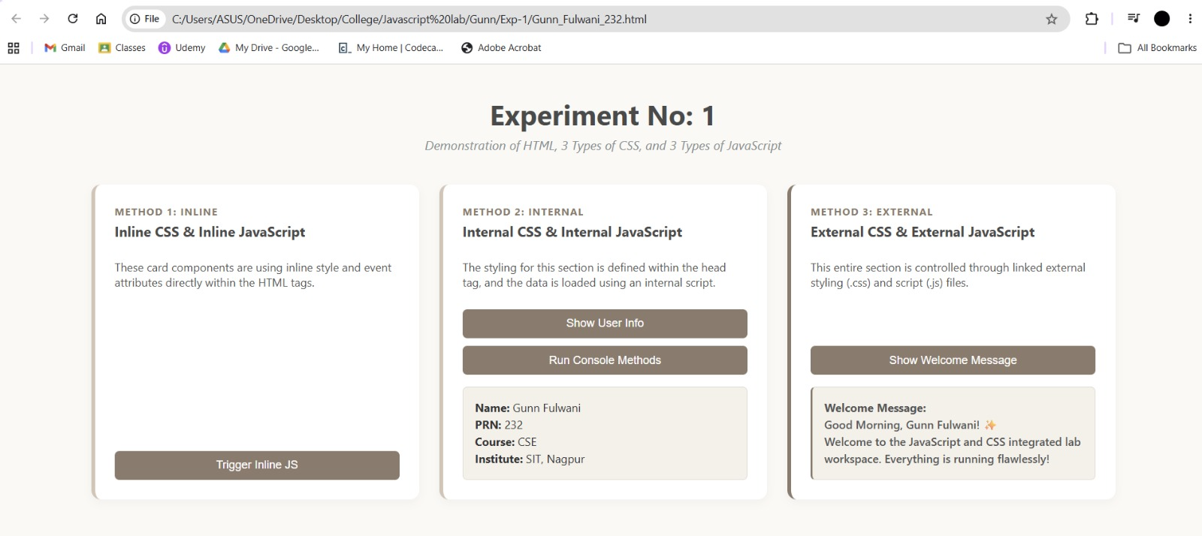

Result/Conclusion: The experiment was successfully completed. The three methods of applying CSS and JavaScript - Inline, Internal, and External - were implemented and practically understood. Furthermore, dynamic DOM manipulation was achieved to display user information and welcome messages upon button clicks. It was observed that utilizing External CSS and JavaScript is the most efficient and maintainable approach for web development, while console methods proved to be essential tools for backend testing and debugging.

